Complete & return to: Vecta Marine, Fordbrook Industrial Estate, Marlborough Road, Pewsey, Wiltshire SN9 5NT
Name of Owner:
Contact Address:

Tel: Fax: email:
Name of Yacht
Make: Model:
Displacement:
Length overall: Beam:
Length Water Line:

Engine make & model:
Horsepower (Max 1 hour rpm rating)……………. @ rpm …………..
Reduction Gear Ratio in Ahead:
Reduction Gear Ratio in Astern:
Rotation in Ahead (viewed from astern):
Normal cruising rpm:

NB: All Saildrives have the same reduction ratio in ahead & astern & normally rotate in a left handed or counter clockwise direction
Shaft drive – see separate page

Saildrive:

Model No:

All Saildrives except Nanni, Beta & Selva have SAE 16/32 Splines on a 28mm shaft with an M16 x 2 nut & rotate anticlockwise in ahead. New Volvos may rotate in either direction.
Yanmar SD40 Saildrives require M20 x 2 nuts.

Page 1/2
Existing Propeller:
Make: Type: No. of Blades:
Diameter: Pitch:
Please describe any problems with this propeller:
page 2/2
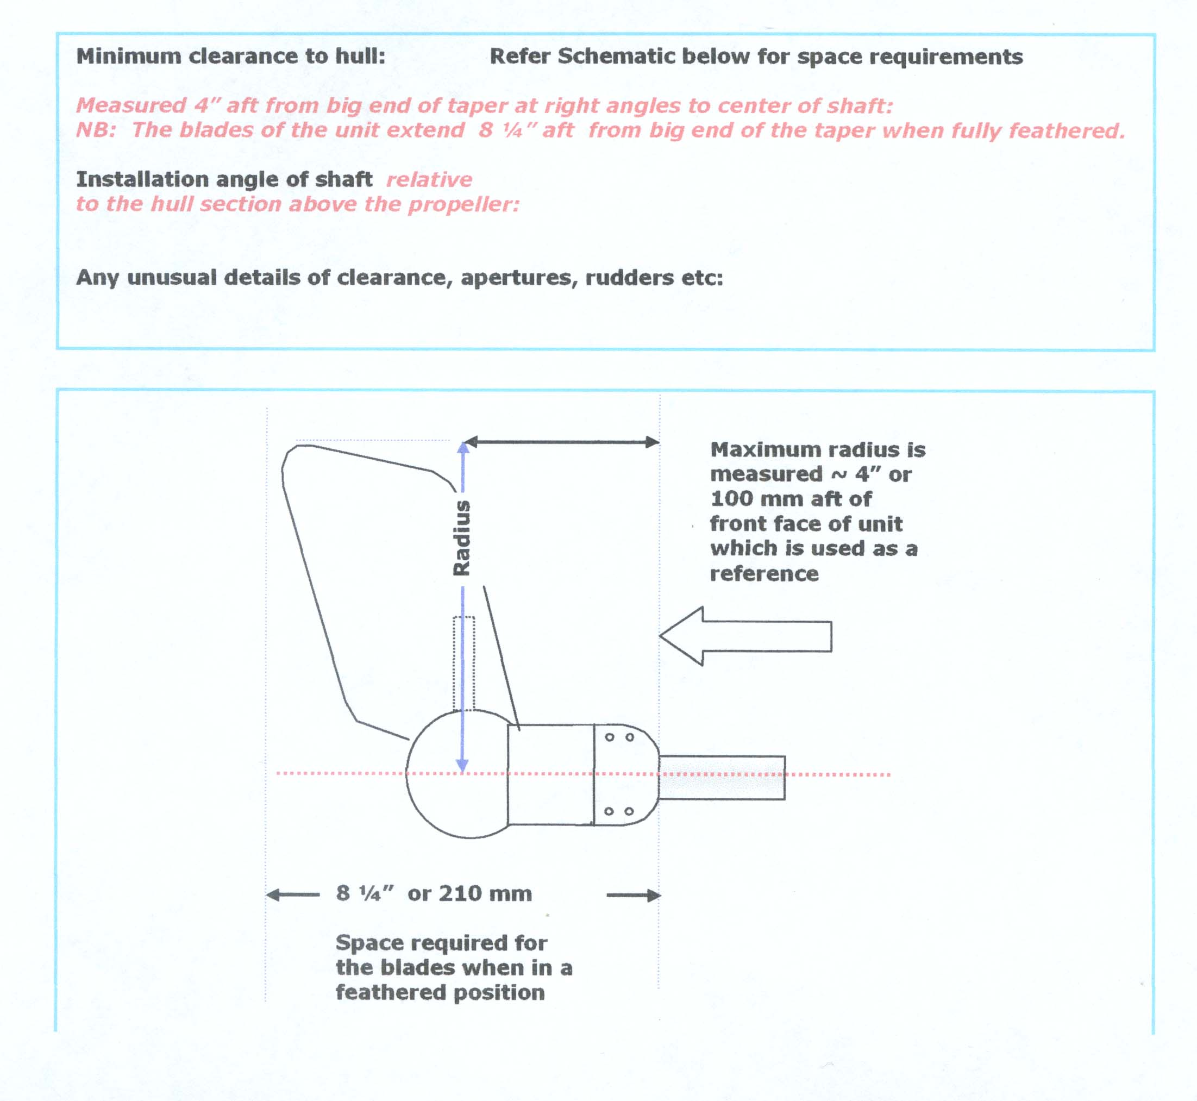
Minimum clearance to hull: Refer to schematic below for space requirements

Measured 4" aft from big end of taper at right angles to centre of shaft:
NB The blades of the unit extend 8 ¼" aft from big end of the taper when fully feathered.

Installation angle of shaft relative to the hull section above the propeller:

Any unusual details of clearance, apertures, rudders etc:

